TASK # 02



Spring 2024
CSE-307L Microprocessor Based System Design Lab

Submitted by: Ali Asghar
Registration No.: 21PWCSE2059
Class Section: C

“On my honor, as student of University of Engineering and Technology, I have neither given nor received unauthorized assistance on this academic work.”

Submitted to:
Dr. Asif Ali Khan

Date:
9th May 2024

Department of Computer Systems Engineering
University of Engineering and Technology, Peshawar

Task:
Write C language code to
- Generate a signal on pin P1.2 having a frequency equal to 200 Hz with a duty cycle of 40%.
- When a user presses a button at P1.1 the frequency changes to 100Hz with a 60% duty cycle.
- Show it on an oscilloscope. Use only Proteus.
- Each time a user presses a button the signal toggles from A to B and then B to A on the next subsequent press

Calculations:
$$f_{1}=200Hz$$
$$T_{1}=\frac{1}{f_{1}}=\frac{1}{200}=0.005s=5ms$$
$$On-time=40\% of 5ms=2ms$$
$$Off-time=60\% of 5ms=3ms$$

$$f_{2}=100Hz$$
$$T_{2}=\frac{1}{f_{2}}=\frac{1}{100}=0.01s=10ms$$
$$On-time=60\% of 10ms=6ms$$
$$Off-time=40\% of 10ms=4ms$$

Code:
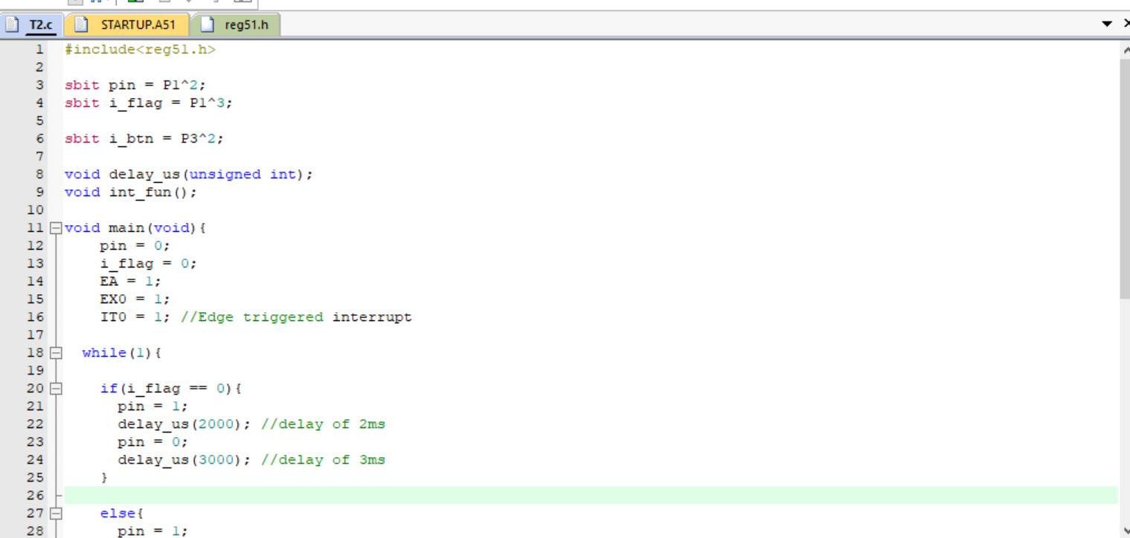
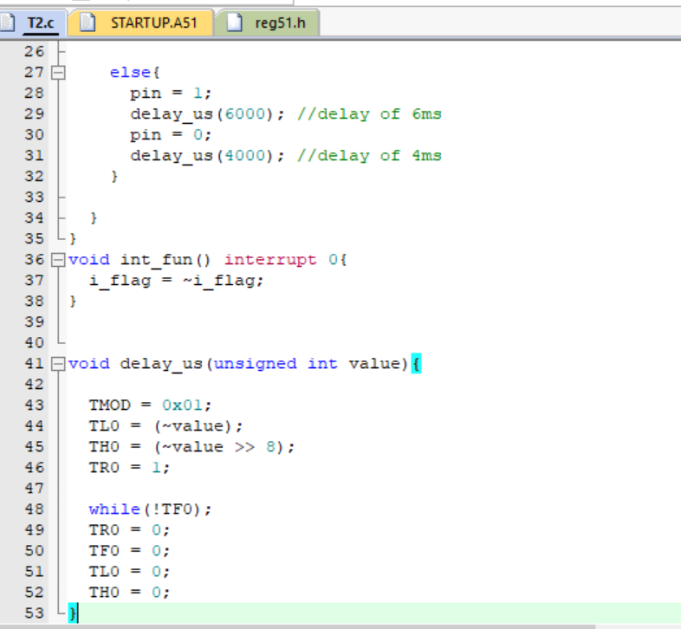

Proteus Simulation:
